Literature Review:
Paper | Models | Tasks | Main Finding | Limitation
Energy Measurement Study for Vision-Language Model Inference: A Single-GPU Empirical Analysis. | SmolVLM2, Qwen3.5-VL, LLaVA | Single-GPU inference profiling & precision testing | Token generation (decoding) uses substantially more energy than visual processing; shorter output length and FP16 precision reduce energy. | Preliminary results that lack external validation and broad workload generalization.
Seeing is Free, Speaking is Not: Uncovering the True Energy Bottleneck in Edge VLM Inference | InternVL3 (1B–8B), Qwen2-VL (2B), Qwen2.5-VL (3B/7B), Gemma-3 (4B) | On-device inference, image captioning, short Q&A | Generating output text consumes 86%–97% of total energy; controlling response length saves up to 97% energy, whereas pruning visual tokens saves under 10%. | Tested only on single-agent edge setups with a batch size of 1.
FastVLM (Vasu et al.) | FastVLM (FastViTHD paired with Qwen2 & Vicuna) | Visual Question Answering (GQA, TextVQA, DocVQA) & general VLM benchmarks | Generates 4×–16× fewer visual tokens, speeding up the Time-To-First-Token (TTFT) by over 3× overall and up to 85× compared to LLaVA-OneVision. | Measures initial latency (TTFT) rather than direct electrical energy draw in Joules.
SparseVLM (Yuan Zhang et al.) | SparseVLM (applied to LLaVA, Mini-Gemini, Qwen2-VL, Video-LLaVA) | Image VQA (GQA, TextVQA, POPE) & Video Question Answering | Uses text prompts to prune unnecessary visual tokens without extra training, cutting latency by ~37%–43% while keeping ~97% accuracy. | Accuracy drops under extreme pruning ratios, and selecting text guidance adds minor compute overhead.

VLM optimization:
- Decreasing encoding latency.
- Decreasing Visual Token Number( Encoding token) while sent to LLM
- Decreasing Decoding Token Number.
Total Energy ≈ Prefill Energy + Decode Energy + Other Overhead
shorter output length reduce up to 97% energy.

Our Baseline Paper Already has done:
- Power is a model-intrinsic constant (<5% variation regardless of resolution, content, prompt) — so all energy variation reduces to time variation. They even prove this with a roofline-based formal bound (Proposition 1).
- Decode dominates 86–97% of energy across InternVL3-1B/2B, Qwen2-VL-2B, Qwen2.5-VL-3B, Gemma-3-4B, on general captioning/VQA-style prompts, up to 896×896.
- Visual token pruning has a hard ceiling: removing 100% of visual tokens saves ≤10% energy for fixed-token models, only 3–4% for their 7–8B models — with a formal proof (Proposition 2) that the ceiling equals the prefill energy share.
- Output length control saves up to 97% — 2–24× more effective than pruning.
- A universal linear energy predictor (model size × N_in × N_out interactions) hits R²=0.986.

Their Gap:
1. Zero accuracy measurement, anywhere in the paper. They measure energy, latency, and output length — never once whether more visual computation improves task performance. This is a complete gap. Your H3 is entirely untouched.
2. Their own data hints at a crossover they never chase down. For Qwen2.5-VL-3B, prefill energy share climbs from 6% at 224×224 to 54% at 896×896 — they've already crossed 50% VED, right at their resolution ceiling, and they stop there. They never push resolution further, never ask where it hits 70% or 90%. Your H4 (crossover thresholds) is sitting exactly where they left off.
3. Single task family. Their resolution sweep uses one open-ended "Describe this image" prompt (plus a separate short-answer probe at one fixed resolution, never crossed with resolution). No OCR, no document understanding, no fine-grained VQA — the exact task types that would naturally combine very high resolution (to keep small text legible) with naturally short output (an extracted field or a one-word answer). That combination is precisely the condition most likely to tip into genuine vision-dominance, and they never test it.
4. Output length isn't held fixed — it's naturalistic. Their NoutN_{out} Nout​ actually drifts with resolution (146→102→107→109 tokens for Qwen2.5-VL-3B across the sweep), which is a confound they don't fully control for. Your original plan — force min_new_tokens = max_new_tokens — is methodologically cleaner than what they did.
5. Full mechanistic analysis stops at 4B. The 7–8B models only get the pruning-savings summary table, not the full decomposition/roofline treatment. Nothing above 8B at all.
6. No video, no multi-frame input — purely single static images, matching your earlier "frame count" question, which remains completely open.

Our Key Contributions & Unanswered Questions :
- Mapping the "Seeing vs. Speaking" Phase-Transition Boundary: Zhan et al. established that "speaking is not free"214, but noted that dynamic tokenization (e.g., Qwen2.5-VL) causes prefill energy to grow up to 54% of total energy at 896*896 resolution. Your research idea answers: At what exact visual token count, image resolution, or frame count does visual prefill energy cross 50%, 70% or 90% of total inference energy?
- First task-conditioned energy crossover result. Zhan et al. showed decode dominates (86–97%) for general captioning/VQA up to 896px. We show this flips for OCR/document tasks, where visual energy can cross 70–90% of the total — the regime their study never reached
- A localized, quantitative threshold — not just "vision gets expensive," but the exact resolution/visual-token count at which each architecture crosses 50%, 70%, 90% visual energy share, extending Zhan et al.'s formal prefill-share bound into a task-conditioned version.
- The first energy-accuracy joint result for VLMs. Zhan et al. measure energy alone; we pair it with real task accuracy, showing whether the extra visual energy in the crossover regime actually buys better performance, or is spent for nothing past a clear elbow.
- • A scale test that could overturn their scaling claim. Zhan et al. found decode dominance strengthens with model size on general tasks — we test whether that holds for OCR/document tasks at 32B scale, or reverses.

Research Question:
When does looking at an image become more expensive than generating the answer—and is the extra visual energy actually worth it?

Our Hypothesis:

H1 — Task Crossover
Does OCR/document understanding make the VLM spend much more energy on seeing the image than general captioning does?

H2 — Finding the Crossover Point
At what image resolution or visual-token count does visual processing become more expensive than text generation? Does this point change for different models and tasks?

H3 — Is the Extra Energy Worth It?
When we increase image resolution, does accuracy improve enough to justify the extra energy, or does accuracy stop improving after a certain point?

H4 — Model Size vs. Task
For larger VLMs, does text generation still use most of the energy on OCR/document tasks, or does high-resolution image processing become more expensive?

Tentative Design Diagram:
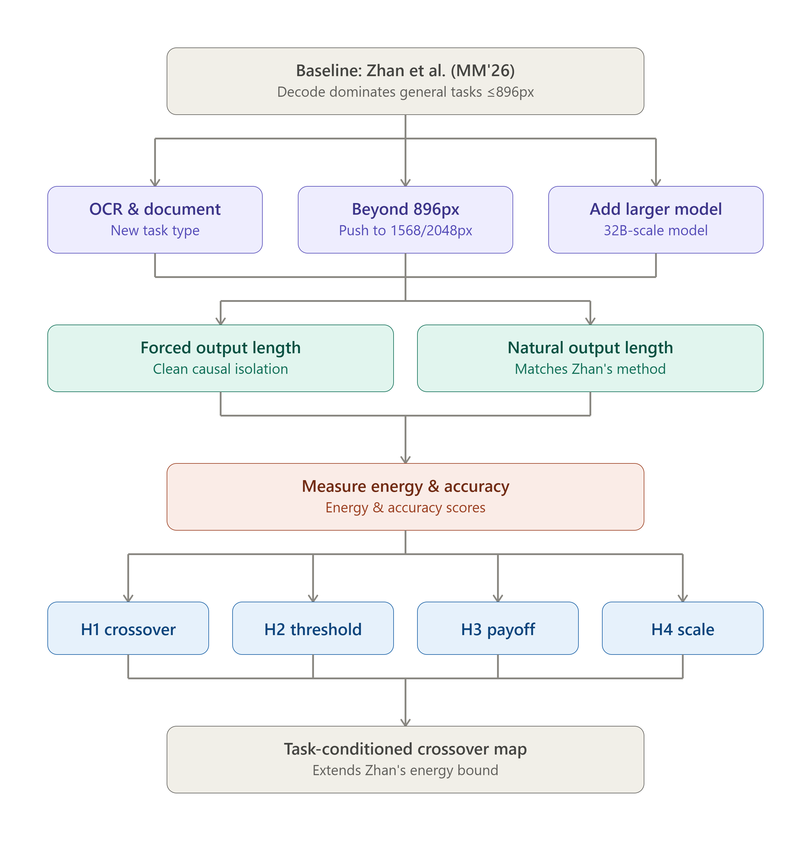

1.To test the VLMs we use:
image resolution
visual complexity
prompt complexity
task difficulty

